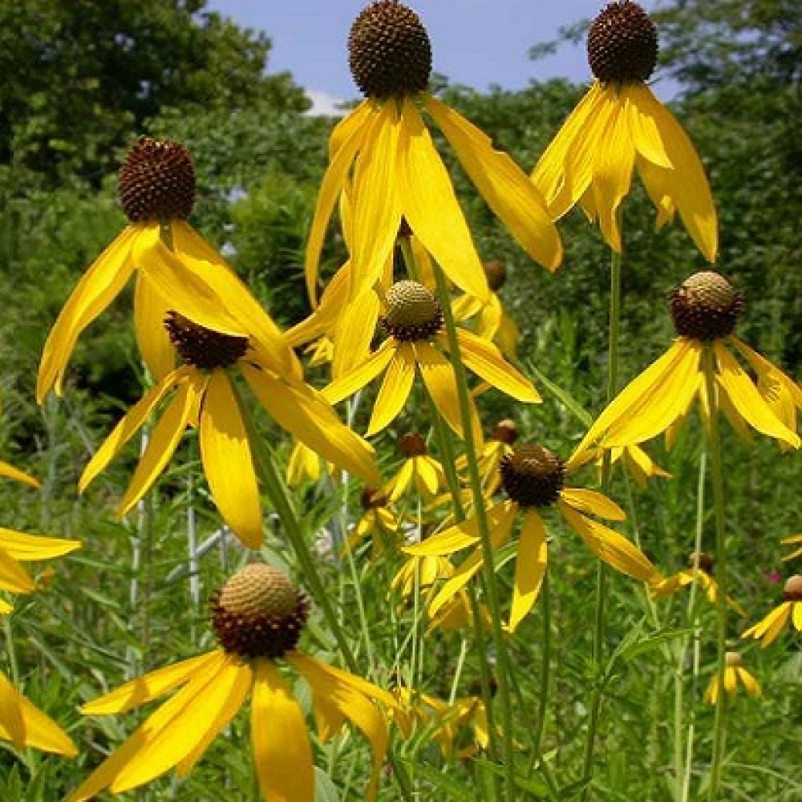
Prairie Coneflower/ Grey Headed Coneflower Ratibida pinnata

*Full to Part sun *Deer resistant *Drought tolerant *Excellent pollinator *3ft-5ft tall *Produces an abundance of seeds songbirds love

